TUD

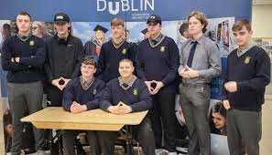https://www.google.com/imgres?imgurl=https%3A%2F%2Fwww.tudublin.ie%2Fmedia%2Fwebsite%2Fconnect%2Fcommunities%2Fpath-3%2Fimages%2F873x500-Engineering-workshop-3.jpg&imgrefurl=https%3A%2F%2Fwww.tudublin.ie%2Fconnect%2Fcommunities%2Fpath-3%2Fschools-outreach%2Ftaster-workshops%2F&tbnid=Yql412pArRHcLM&vet=12ahUKEwjFta_Ro_b7AhUqXaQEHYX1CD4QMygCegUIARDBAQ..i&docid=keOEuYuYNTuq-M&w=873&h=500&q=Technological%20University%20Dublin%20workshop&ved=2ahUKEwjFta_Ro_b7AhUqXaQEHYX1CD4QMygCegUIARDBAQ

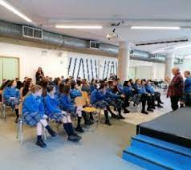https://www.google.com/imgres?imgurl=https%3A%2F%2Fwww.tudublin.ie%2Fmedia%2Fwebsite%2Fconnect%2Fcommunities%2Fpath-3%2Fimages%2F308x275-Maths-Workshop-Group-Oct-22.jpg&imgrefurl=https%3A%2F%2Ftudublin.ie%2Fconnect%2Fcommunities%2Fpath-3%2Fevents%2F&tbnid=ge2LsPmZOyDJ5M&vet=12ahUKEwjFta_Ro_b7AhUqXaQEHYX1CD4QMygBegUIARC_AQ..i&docid=KOmhScLeIyhpVM&w=308&h=275&q=Technological%20University%20Dublin%20workshop&ved=2ahUKEwjFta_Ro_b7AhUqXaQEHYX1CD4QMygBegUIARC_AQ

UCD

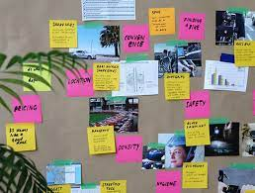

<https://www.google.com/imgres?imgurl=https%3A%2F%2Fwww.ucd.ie%2Finnovation%2Fresearchers-and-students%2Fcommercialisation-bootcamp%2Fworkshops%2Fworkshop-2nd-image.jpg&imgrefurl=https%3A%2F%2Fwww.ucd.ie%2Finnovation%2Fresearchers-and-students%2Fcommercialisation-bootcamp%2Fworkshops%2F&tbnid=lI43b8f0SBMtBM&vet=12ahUKEwiNgeX1o_b7AhXhUKQEHZzOBn4QMygAegUIARC7AQ..i&docid=-OGqN8fXS4HfgM&w=611&h=462&q=University%20College%20Dublin%20workshop&ved=2ahUKEwiNgeX1o_b7AhXhUKQEHZzOBn4QMygAegUIARC7AQ>

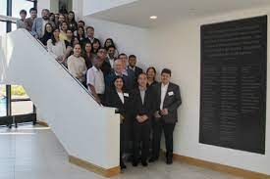https://www.google.com/imgres?imgurl=https%3A%2F%2Fhymedpoly.eu%2Fwp-content%2Fuploads%2F2018%2F07%2F2018-06-22_dublin3.png%3Fx86240&imgrefurl=https%3A%2F%2Fhymedpoly.eu%2F2018%2F07%2F02%2Fhymedpoly-open-workshop-from-science-to-products-and-plenary-meeting-dublin-21-and-22-june-2018%2F&tbnid=4KFtCKWlcXRYeM&vet=12ahUKEwiNgeX1o_b7AhXhUKQEHZzOBn4QMygRegUIARDhAQ..i&docid=HCMkBmkbAzBTDM&w=489&h=325&itg=1&q=University%20College%20Dublin%20workshop&ved=2ahUKEwiNgeX1o_b7AhXhUKQEHZzOBn4QMygRegUIARDhAQ

TCD

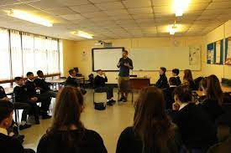https://www.google.com/imgres?imgurl=https%3A%2F%2Fbalbriggancommunitycollege.com%2Fwp-content%2Fuploads%2F2016%2F10%2FIMG_0042-scaled-1.jpg&imgrefurl=https%3A%2F%2Fbalbriggancommunitycollege.com%2Ftrinity-college-dublin-cfes-leadership-through-service%2F&tbnid=yt_Vjul_Utml9M&vet=12ahUKEwj3w-OUpPb7AhVQ0oUKHWqAD1gQMygBegUIARDAAQ..i&docid=Zxo2QSFg6QmYMM&w=2560&h=1707&q=Trinity%20College%20Dublin%20workshop&ved=2ahUKEwj3w-OUpPb7AhVQ0oUKHWqAD1gQMygBegUIARDAAQ

<https://www.google.com/imgres?imgurl=https%3A%2F%2Fwww.shapeid.eu%2Fwp-content%2Fuploads%2F2019%2F12%2Fshape-three.jpg&imgrefurl=https%3A%2F%2Fwww.shapeid.eu%2Ffirst-shape-id-workshop-takes-place-at-trinity-college-dublin%2F&tbnid=knRac95M3Y7KxM&vet=12ahUKEwj3w-OUpPb7AhVQ0oUKHWqAD1gQMygEegUIARDGAQ..i&docid=V3LyAjXbw1VS_M&w=4682&h=4000&q=Trinity%20College%20Dublin%20workshop&ved=2ahUKEwj3w-OUpPb7AhVQ0oUKHWqAD1gQMygEegUIARDGAQ>

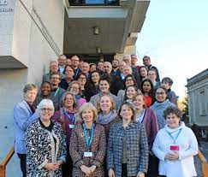

National College of Ireland

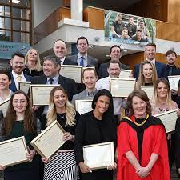

<https://www.google.com/imgres?imgurl=https%3A%2F%2Fwww.ncirl.ie%2FPortals%2F0%2FImages%2F450x450-Cards-Teasers%2Fimg-students-alumni-spotlight.jpg&imgrefurl=https%3A%2F%2Fwww.ncirl.ie%2F&tbnid=2ve7GMLODkGsYM&vet=12ahUKEwiim-q-pPb7AhVhrycCHVwbAZMQMygSegUIARDGAQ..i&docid=4FRYOy2sBF6QnM&w=450&h=450&q=National%20College%20of%20Ireland%20workshop&ved=2ahUKEwiim-q-pPb7AhVhrycCHVwbAZMQMygSegUIARDGAQ>

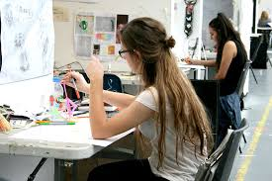https://www.google.com/imgres?imgurl=https%3A%2F%2Fwww.ncad.ie%2Ffiles%2Fundergrad_files%2Ffirst-year-studies-ncad-001.jpg&imgrefurl=https%3A%2F%2Fwww.ncad.ie%2Fundergraduate%2Ffirst-year%2F&tbnid=JHJAmZZcLgXdsM&vet=12ahUKEwiim-q-pPb7AhVhrycCHVwbAZMQMygmegUIARD2AQ..i&docid=NkRIjFU0YCtK1M&w=800&h=533&q=National%20College%20of%20Ireland%20workshop&ved=2ahUKEwiim-q-pPb7AhVhrycCHVwbAZMQMygmegUIARD2AQ

DCU

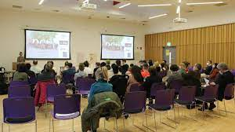https://www.google.com/imgres?imgurl=https%3A%2F%2Fwww.dcu.ie%2Fsites%2Fdefault%2Ffiles%2Fstyles%2Fwidescreen_television%2Fpublic%2Faccess_editor%2F2022-09%2FIMG_8978%2520%25281%2529.JPG%3Fitok%3D31CCV3wd&imgrefurl=https%3A%2F%2Fwww.dcu.ie%2Faccess%2Fnews%2F2022%2Fsep%2Fchange-makers-workshop&tbnid=RkdIPluVzGGYjM&vet=12ahUKEwig4KnjpPb7AhVhoCcCHXVYC4UQMygBegUIARC6AQ..i&docid=92MEiAH7KQLaEM&w=1200&h=674&q=Dublin%20City%20University%20workshop&ved=2ahUKEwig4KnjpPb7AhVhoCcCHXVYC4UQMygBegUIARC6AQ

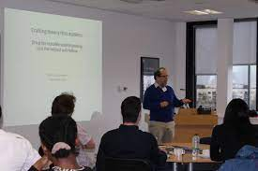https://www.google.com/imgres?imgurl=https%3A%2F%2Fwww.dcu.ie%2Fsites%2Fdefault%2Ffiles%2Fstyles%2Fwidescreen_television%2Fpublic%2Fmedia%2F2016%2F11%2F22%2Fsimfinal.jpg%3Fitok%3DuEQxXsKk&imgrefurl=https%3A%2F%2Fwww.dcu.ie%2Fleadership-talent%2Fnews%2F2016%2F11%2Fthe-leadership-and-talent-institute-hosts-international-publication&tbnid=iYoqYgpv9u5eaM&vet=12ahUKEwig4KnjpPb7AhVhoCcCHXVYC4UQMygJegUIARDKAQ..i&docid=Gw5dp34SBFM96M&w=1200&h=800&itg=1&q=Dublin%20City%20University%20workshop&ved=2ahUKEwig4KnjpPb7AhVhoCcCHXVYC4UQMygJegUIARDKAQ

Griffith college

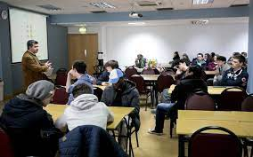https://www.google.com/imgres?imgurl=https%3A%2F%2Fwww.griffith.ie%2Fsites%2Fdefault%2Ffiles%2Fstorage%2F%2Fjuicebox_large%2FxComputing%2CP20Workshop-0005_1.jpg%2Cqitok%3Df1l9ftNF.pagespeed.ic.Yi3GCjyr0A.jpg&imgrefurl=https%3A%2F%2Fwww.griffith.ie%2Fabout-griffith%2Fgallery%2Fgames-development-workshop-2015&tbnid=2U66XriVez6huM&vet=12ahUKEwid3cGDpfb7AhV7sScCHRofDocQMygHegUIARC8AQ..i&docid=AmbNTKClovvMdM&w=800&h=500&q=Griffith%20College%20workshop&ved=2ahUKEwid3cGDpfb7AhV7sScCHRofDocQMygHegUIARC8AQ

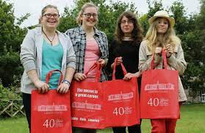

<https://www.google.com/imgres?imgurl=https%3A%2F%2Fwww.independent.ie%2Fregionals%2Fwicklowpeople%2Fnews%2Fac048%2F30453353.ece%2FAUTOCROP%2Fw620%2FNWS_20140723_New_016_32210476_I1.JPG&imgrefurl=https%3A%2F%2Fwww.independent.ie%2Fregionals%2Fwicklowpeople%2Flocalnotes%2Fstudents-attend-computing-workshop-in-griffith-college-30453354.html&tbnid=2lfGavCm6xcGjM&vet=12ahUKEwid3cGDpfb7AhV7sScCHRofDocQMygJegUIARDAAQ..i&docid=9PkB5ErpWtrkLM&w=620&h=403&q=Griffith%20College%20workshop&ved=2ahUKEwid3cGDpfb7AhV7sScCHRofDocQMygJegUIARDAAQ>

DBS

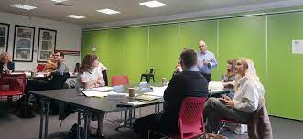https://www.google.com/imgres?imgurl=https%3A%2F%2Fbusiness.dcu.ie%2Fwp-content%2Fuploads%2F2019%2F11%2FEHoPWC6WkAA0M7D-e1573476422883.jpg&imgrefurl=https%3A%2F%2Fbusiness.dcu.ie%2Fdesign-thinking-workshop%2F&tbnid=cxo-DJT1LX_1nM&vet=12ahUKEwiE5_Cupfb7AhWcmicCHS4_BKkQMygCegUIARC4AQ..i&docid=WX10JS35EVkQ-M&w=2048&h=942&q=Dublin%20Buisness%20school%20workshop&ved=2ahUKEwiE5_Cupfb7AhWcmicCHS4_BKkQMygCegUIARC4AQ

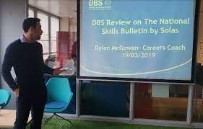https://www.google.com/imgres?imgurl=https%3A%2F%2Fstudents.dbs.ie%2Fimages%2Fdefault-source%2Fsesu-images%2Fdylan-careers-coach.jpg%3Fsfvrsn%3D4e9f47d3_2&imgrefurl=https%3A%2F%2Fstudents.dbs.ie%2Fnews%2F2019%2F03%2F29%2Fcareers-workshops&tbnid=FxiA4d6QRfINmM&vet=12ahUKEwiE5_Cupfb7AhWcmicCHS4_BKkQMygAegUIARC0AQ..i&docid=dxoxGkXrqKWqTM&w=1251&h=798&itg=1&q=Dublin%20Buisness%20school%20workshop&ved=2ahUKEwiE5_Cupfb7AhWcmicCHS4_BKkQMygAegUIARC0AQ

University of Limerick

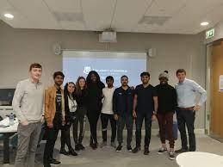https://www.google.com/imgres?imgurl=https%3A%2F%2Fimages.squarespace-cdn.com%2Fcontent%2Fv1%2F5d892f94afd4fc4e074a830f%2F1573836664571-7RNCD7UP137L2HIW0Z11%2FAmbassador%2Bworkshop%2B5.jpeg&imgrefurl=https%3A%2F%2Fwww.campusconnect.ie%2Fnews-events%2Fcampusconnect-ambassador-program-2020-university-of-limerick&tbnid=lqxN8pFNtxD8AM&vet=12ahUKEwiFta3Epfb7AhURTKQEHen-BSIQMygQegUIARDhAQ..i&docid=989H6TkVm-ET0M&w=1600&h=1200&itg=1&q=University%20of%20Limerick%20workshop&ved=2ahUKEwiFta3Epfb7AhURTKQEHen-BSIQMygQegUIARDhAQ

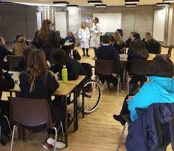https://www.google.com/imgres?imgurl=https%3A%2F%2Feitrawmaterialsrace.com%2Fwp-content%2Fuploads%2F2018%2F01%2FPicture2.png&imgrefurl=https%3A%2F%2Feitrawmaterialsrace.com%2Funiversity-of-limerick-workshop-series%2F&tbnid=R8PL-_HnDk5ykM&vet=12ahUKEwiFta3Epfb7AhURTKQEHen-BSIQMygJegUIARDTAQ..i&docid=d1potX7JYkUCYM&w=678&h=588&q=University%20of%20Limerick%20workshop&ved=2ahUKEwiFta3Epfb7AhURTKQEHen-BSIQMygJegUIARDTAQ

Munster university

https://www.google.com/imgres?imgurl=https%3A%2F%2Fpbs.twimg.com%2Fmedia%2FFjUXDe_XEA0k1mu%3Fformat%3Djpg%26name%3Dlarge&imgrefurl=https%3A%2F%2Fmobile.twitter.com%2Fmtu_ie&tbnid=xdxnpp0nDfYzqM&vet=12ahUKEwihssbgpfb7AhWHnycCHVPgAokQMygGegUIARCcAQ..i&docid=FPUiQfa7ZSGkLM&w=2048&h=1536&q=Munster%20Technological%20University%20%20workshop&ved=2ahUKEwihssbgpfb7AhWHnycCHVPgAokQMygGegUIARCcAQ

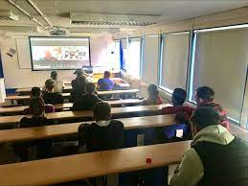https://www.google.com/imgres?imgurl=https%3A%2F%2Fmedia-exp1.licdn.com%2Fdms%2Fimage%2FC4E22AQHPU-dX1fKFhw%2Ffeedshare-shrink_2048_1536%2F0%2F1666254630496%3Fe%3D2147483647%26v%3Dbeta%26t%3Dfe1UbluC1jNftOha1VdGTFlgj0oCFVdB-dJUSMB2NZY&imgrefurl=https%3A%2F%2Fie.linkedin.com%2Fin%2Ffaculty-of-engineering-and-science-munster-technological-university-cork-campus-96033316&tbnid=69yXtKUfCt_SqM&vet=12ahUKEwihssbgpfb7AhWHnycCHVPgAokQMygSegUIARC3AQ..i&docid=UFsYpwDh8za6KM&w=750&h=563&q=Munster%20Technological%20University%20%20workshop&ved=2ahUKEwihssbgpfb7AhWHnycCHVPgAokQMygSegUIARC3AQ

UCC

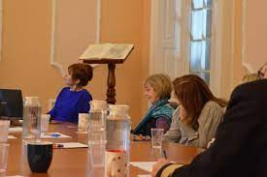https://www.google.com/imgres?imgurl=https%3A%2F%2Fwww.ucc.ie%2Fen%2Fmedia%2Fresearch%2Fkeynes%2Fkcimages%2FWorkshop-1-601x400.jpg&imgrefurl=https%3A%2F%2Fwww.ucc.ie%2Fen%2Fkeynes%2Fdevelopmentalexperiences%2Fgrowingyourorganisation%2Fgrowingyourfirmworkshop%2F&tbnid=n8MvZnSX3n0bTM&vet=12ahUKEwjdytH_pfb7AhWGsScCHTrRDnAQMygCegUIARC_AQ..i&docid=IVm00lyax-0P_M&w=601&h=400&q=University%20College%20Cork%20%20workshop&ved=2ahUKEwjdytH_pfb7AhWGsScCHTrRDnAQMygCegUIARC_AQ

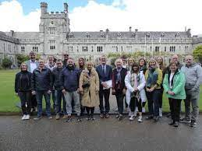https://www.google.com/imgres?imgurl=https%3A%2F%2Fwww.ucc.ie%2Fen%2Fmedia%2Fresearch%2Ffitu%2Fnewandeventsphotos%2FDFMMclassApril2022no2-533x400.JPG&imgrefurl=https%3A%2F%2Fwww.ucc.ie%2Fen%2Ffitu%2Fnewsevents%2Fgreat-to-welcome-the-diploma-in-food-manufacturing-management-class-of-2022-to-ucc.html&tbnid=E7yRV0lnUNKaXM&vet=12ahUKEwjdytH_pfb7AhWGsScCHTrRDnAQMygHegUIARDJAQ..i&docid=g54wQl84nK9xSM&w=533&h=400&q=University%20College%20Cork%20%20workshop&ved=2ahUKEwjdytH_pfb7AhWGsScCHTrRDnAQMygHegUIARDJAQ

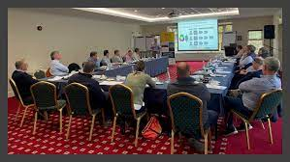https://www.google.com/imgres?imgurl=https%3A%2F%2Fwww.ucc.ie%2Fen%2Fmedia%2Fresearch%2Ffitu%2Fdiplomaincorporatedirection%2FDiplomainCorporateDirectionClassDec2022-711x400.png&imgrefurl=https%3A%2F%2Fwww.ucc.ie%2Fen%2Ffitu%2Fnewsevents%2F&tbnid=D8bQ9rrAZX4BjM&vet=12ahUKEwjdytH_pfb7AhWGsScCHTrRDnAQMygSegUIARDfAQ..i&docid=-_4GnZwvdW0VIM&w=711&h=400&q=University%20College%20Cork%20%20workshop&ved=2ahUKEwjdytH_pfb7AhWGsScCHTrRDnAQMygSegUIARDfAQ

Technological university of shanon



<https://www.google.com/imgres?imgurl=https%3A%2F%2Fwww.irishtimes.com%2Fresizer%2FEhROgdi-NquGbuzupKUD8eZ3VKw%3D%2F400x225%2Ffilters%3Aformat(jpg)%3Aquality(70)%2Fcloudfront-eu-central-1.images.arcpublishing.com%2Firishtimes%2FZLPP3NTIITXR7Y2M44S6IJR24Y.jpg&imgrefurl=https%3A%2F%2Fwww.irishtimes.com%2Ftags%2Ftechnological-university-of-the-shannon%2F&tbnid=4n93zYOe5mbxSM&vet=12ahUKEwimvMK4pvb7AhW_UqQEHeeJDk4QMygBegQIARBS..i&docid=Y8k_G4wfyN4ZEM&w=400&h=225&itg=1&q=Technological%20University%20of%20the%20Shannon%20workshop&ved=2ahUKEwimvMK4pvb7AhW_UqQEHeeJDk4QMygBegQIARBS>

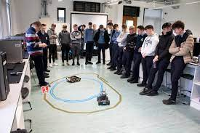https://www.google.com/imgres?imgurl=https%3A%2F%2Fwww.ait.ie%2Fuploads%2Fgeneral%2Frobotics22.jpg&imgrefurl=https%3A%2F%2Fwww.ait.ie%2Fnews-and-events%2Fnews%2Fait-special-subject-workshops-prepare-leaving-certificate-students-for-exam&tbnid=eMSYXCI5F63UDM&vet=12ahUKEwimvMK4pvb7AhW_UqQEHeeJDk4QMygLegQIARBm..i&docid=zAAXwtR0Owc1sM&w=5472&h=3648&q=Technological%20University%20of%20the%20Shannon%20workshop&ved=2ahUKEwimvMK4pvb7AhW_UqQEHeeJDk4QMygLegQIARBm

Dundalk institute of technology

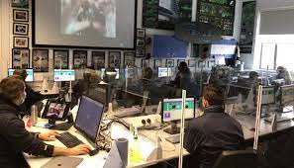https://www.google.com/imgres?imgurl=https%3A%2F%2Fwww.dkit.ie%2Fassets%2Fuploads%2FComputing-Workshops-Body-1.jpg&imgrefurl=https%3A%2F%2Fwww.dkit.ie%2Fnews%2Fdkit-launches-new-virtual-computing-skills-workshops-for-secondary-schools.html&tbnid=zGSm_Mkz1tJ0eM&vet=12ahUKEwjlrLHZpvb7AhUqXaQEHYX1CD4QMygAegUIARC6AQ..i&docid=WF3Qz3iS3tEv0M&w=1400&h=800&q=Dundalk%20Institute%20of%20Technology%20workshop&ved=2ahUKEwjlrLHZpvb7AhUqXaQEHYX1CD4QMygAegUIARC6AQ

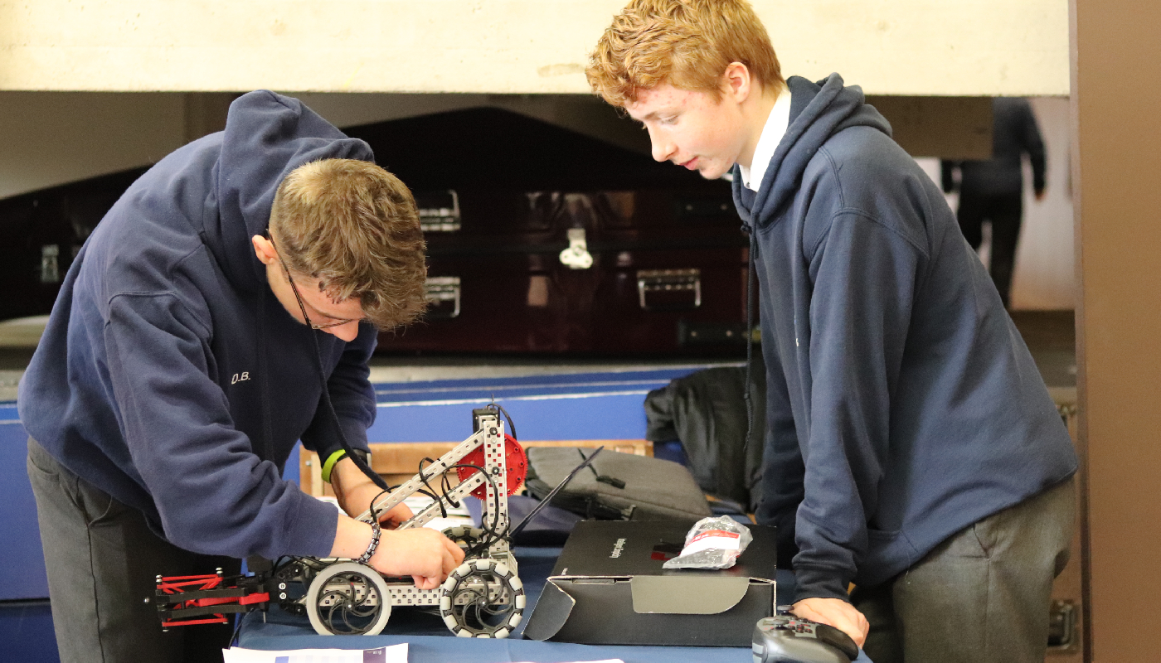https://www.google.com/url?sa=i&url=https%3A%2F%2Fwww.dkit.ie%2Fnews%2Fdkit-hosts-vex-robotics-final.html&psig=AOvVaw0ZcNYxy3b_21FbU0txOzcd&ust=1671010864838000&source=images&cd=vfe&ved=0CBAQjRxqFwoTCPjT19qm9vsCFQAAAAAdAAAAABAE

Atlantic Technological University - Donegal Letterkenny Campus

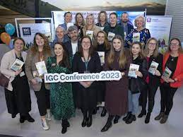

<https://www.google.com/imgres?imgurl=https%3A%2F%2Fwww.atu.ie%2Fsites%2Fdefault%2Ffiles%2Fstyles%2Ftraditional_television%2Fpublic%2F2022-12%2F676A0400.jpg%3Fh%3Db7d6d314%26itok%3DfOOnOmC6&imgrefurl=https%3A%2F%2Fwww.atu.ie%2F&tbnid=dpNI-TFLhwGJIM&vet=12ahUKEwi-gdz8pvb7AhXErycCHTJqAvMQMygFegQIARAw..i&docid=GNa29TDYeBLn6M&w=960&h=720&q=Atlantic%20Technological%20University%20-%20Donegal%20Letterkenny%20Campus%20workshop&ved=2ahUKEwi-gdz8pvb7AhXErycCHTJqAvMQMygFegQIARAw>

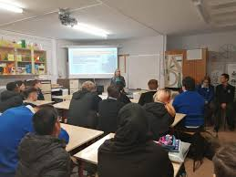https://www.google.com/imgres?imgurl=https%3A%2F%2Flookaside.fbsbx.com%2Flookaside%2Fcrawler%2Fmedia%2F%3Fmedia_id%3D562670659194235&imgrefurl=https%3A%2F%2Fzh-cn.facebook.com%2Fatudonegalofficial%2F&tbnid=5WHBF0Ocp4PBaM&vet=12ahUKEwi-gdz8pvb7AhXErycCHTJqAvMQMygbegQIARBj..i&docid=CXD9GLW9SlMKhM&w=1440&h=1080&itg=1&q=Atlantic%20Technological%20University%20-%20Donegal%20Letterkenny%20Campus%20workshop&ved=2ahUKEwi-gdz8pvb7AhXErycCHTJqAvMQMygbegQIARBj

South East Technological University



<https://www.google.com/imgres?imgurl=https%3A%2F%2Fpbs.twimg.com%2Fmedia%2FFf1RvYuXwAY0GYj%3Fformat%3Djpg%26name%3D360x360&imgrefurl=https%3A%2F%2Fwww.beat102103.com%2Fnews%2Fsouth-east-technological-university-has-officially-been-launched-1032631&tbnid=pq4VHdhy_6iVaM&vet=12ahUKEwi84IHgp_b7AhVJoicCHR0LDdAQMygEegUIARDDAQ..i&docid=wHz1ZI5Xf8rFhM&w=360&h=263&q=South%20East%20Technological%20University%20workshop&ved=2ahUKEwi84IHgp_b7AhVJoicCHR0LDdAQMygEegUIARDDAQ>

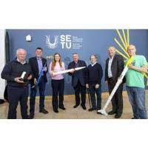https://www.google.com/imgres?imgurl=https%3A%2F%2Fchambermaster.blob.core.windows.net%2Fimages%2Fcustomers%2F3615%2Fnews%2F681%2F200x200%2FSETU-Space-Week.jpg&imgrefurl=https%3A%2F%2Fcrm.waterfordchamber.ie%2Fnews%2Fdetails%2Fsetu-relevance-conference-launches-opportunities-in-the-irish-space-sector&tbnid=bhTRz65KzcDdUM&vet=12ahUKEwi84IHgp_b7AhVJoicCHR0LDdAQMygJegUIARDNAQ..i&docid=5ce4M6tWZACToM&w=200&h=200&itg=1&q=South%20East%20Technological%20University%20workshop&ved=2ahUKEwi84IHgp_b7AhVJoicCHR0LDdAQMygJegUIARDNAQ

Carlow College, St Patrick's

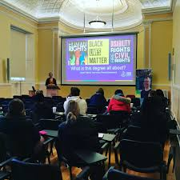

<https://www.google.com/imgres?imgurl=https%3A%2F%2Flookaside.fbsbx.com%2Flookaside%2Fcrawler%2Fmedia%2F%3Fmedia_id%3D2913391358804176&imgrefurl=https%3A%2F%2Fwww.facebook.com%2FCarlowCollegeStPatricks%2F&tbnid=VDwjnLTzTweNVM&vet=12ahUKEwi3mZWJqPb7AhXqXqQEHTI6B80QMygWegUIARDnAQ..i&docid=gXnSYVYv3tza6M&w=1440&h=1440&q=Carlow%20College%2C%20St%20Patrick%27s%20workshop&ved=2ahUKEwi3mZWJqPb7AhXqXqQEHTI6B80QMygWegUIARDnAQ>

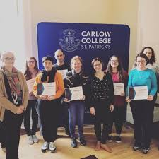

<https://www.google.com/imgres?imgurl=https%3A%2F%2Flookaside.fbsbx.com%2Flookaside%2Fcrawler%2Fmedia%2F%3Fmedia_id%3D1963025280507460&imgrefurl=https%3A%2F%2Fsw-ke.facebook.com%2FCarlowCollegeStPatricks%2Fposts%2Fover-the-past-two-days-weve-had-a-great-group-participating-in-a-p4c-training-wo%2F1963025510507437%2F&tbnid=HRFP3kEg9rzkUM&vet=12ahUKEwi3mZWJqPb7AhXqXqQEHTI6B80QMygfegUIARD-AQ..i&docid=5JQ7H7UE_gWViM&w=960&h=960&itg=1&q=Carlow%20College%2C%20St%20Patrick%27s%20workshop&ved=2ahUKEwi3mZWJqPb7AhXqXqQEHTI6B80QMygfegUIARD-AQ>

NUI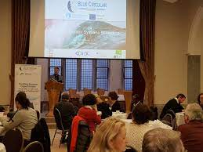

<https://www.google.com/imgres?imgurl=https%3A%2F%2Fbluecirculareconomy.eu%2Fwp-content%2Fuploads%2F2020%2F01%2F20200122_093359.jpg&imgrefurl=https%3A%2F%2Fbluecirculareconomy.eu%2Flocal-innovation-systems-workshop-galway%2F&tbnid=1l3YgYvCMhS2CM&vet=12ahUKEwjLiZSxqPb7AhX3UaQEHa-WCUEQMygFegUIARDEAQ..i&docid=KGBlyiHZIrJPwM&w=4032&h=3024&itg=1&q=NUI%20Galway%20workshop&ved=2ahUKEwjLiZSxqPb7AhX3UaQEHa-WCUEQMygFegUIARDEAQ>

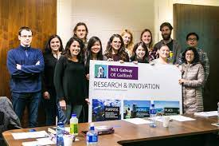https://www.google.com/imgres?imgurl=https%3A%2F%2Fwww.pathsense.eu%2Fwp-content%2Fuploads%2F2017%2F10%2FSecondments.jpg&imgrefurl=https%3A%2F%2Fwww.pathsense.eu%2Ffrom-bench-to-market-training-workshop-starting-up-a-spin-off-company%2F&tbnid=D4Cdk4ejrTW5hM&vet=12ahUKEwjLiZSxqPb7AhX3UaQEHa-WCUEQMygRegUIARDcAQ..i&docid=rSn8O3m4r-aGTM&w=1200&h=800&itg=1&q=NUI%20Galway%20workshop&ved=2ahUKEwjLiZSxqPb7AhX3UaQEHa-WCUEQMygRegUIARDcAQ